**If-then-else vs Switch-case**

There are two really noticeable differences here in comparison between if-then-else and switch. Firstly, break statement is used in switch to exit from case block and secondly there are no equality, inequality, greater than or less than comparisons to be seen in switch which are used in if-then-else.

**break Statement**

In Javascript programming, break is used in terminating the loop immediately after it is encountered. The break statement is used with conditional if statement.

**Syntax of break statement**

break;

The break statement can be used in terminating all three loops for, while and do...while loops.

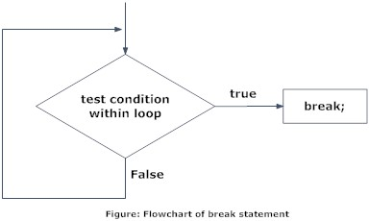

The figure below explains the working of break statement in all three type of loops.

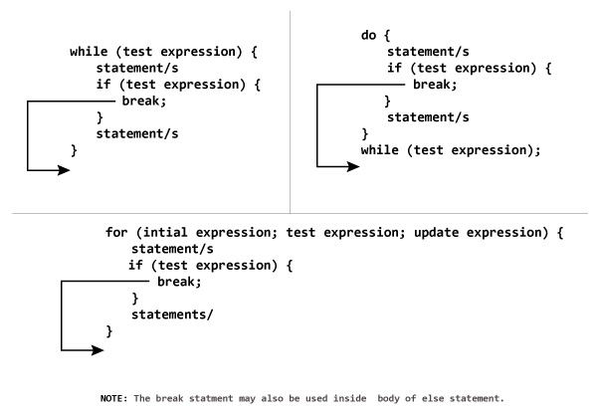

**continue Statement**

It is sometimes desirable to skip some statements inside the loop. In such cases, continue statements are used.

**Syntax of continue Statement**

continue;

Just like break, continue is also used with conditional if statement.

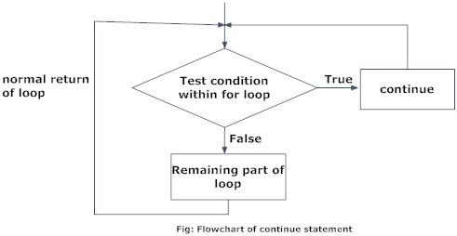

For better understanding of how continue statements works in C programming. Analyze the figure below which bypasses some code/s inside loops using continue statement.

